TWO DEGREE-OF-FREEDOM SYSTEMS
(Undamped Vibration)

Equation of Motion for a 2 dof Coupled System

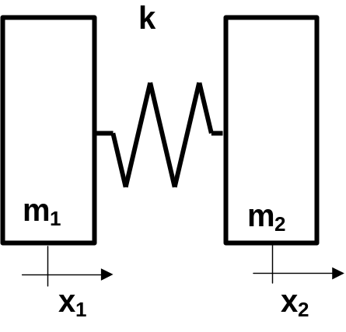
1 – Lagrange’s Equation

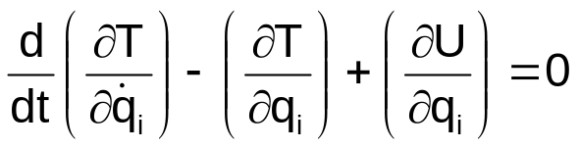
with:
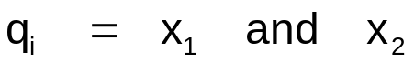

1 – 1 Kinetic Energy
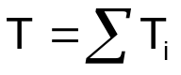 => 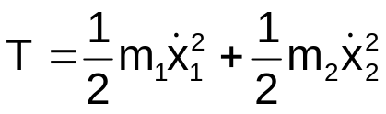
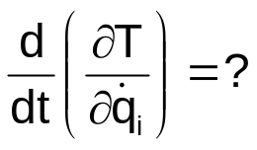
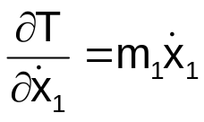
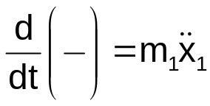
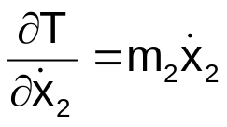
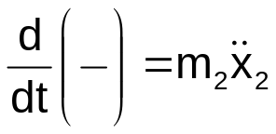
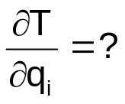
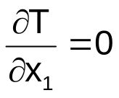
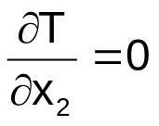
1 – 2 Potential Energy

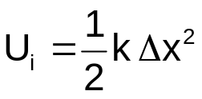

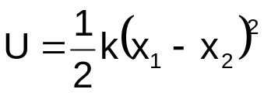

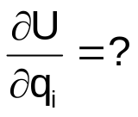
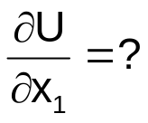
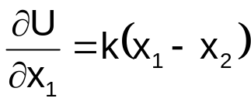

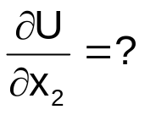
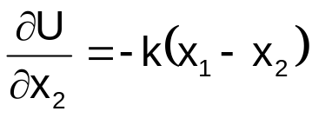
1 – 3 Equation of Motion (undamped)

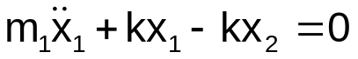
and
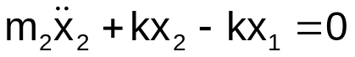

Using a compact form:

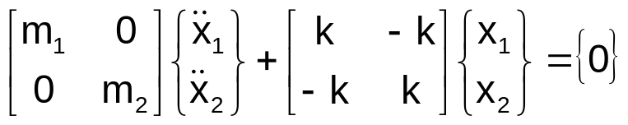

Mass matrix:
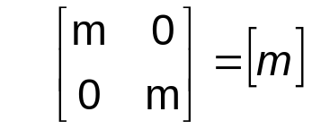
Stiffness matrix:
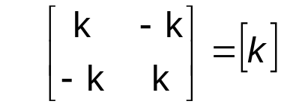

- both matrices are symmetric and diagonal terms are positive
2 – Free Vibration
Natural Vibration of Coupled Systems

A solution is assumed of the form:
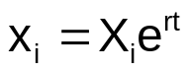

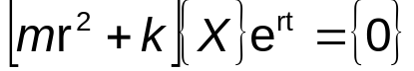

and for any value of t:
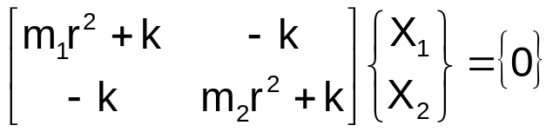

Remind:
Three unknowns (X_{i1}, X_{i2} and r) and two algebraic equations

=> a norm is needed
2 – 1 Natural Frequencies (eigenvalues)

Characteristic equation:

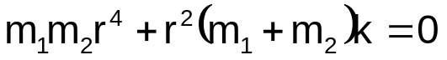

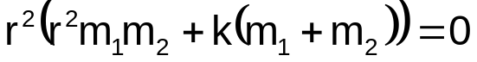

Two roots
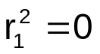 and 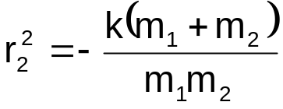

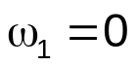 and 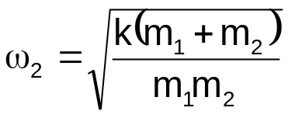
2– 2 Modes (eigenvectors)

For the first angular frequency, the X₁ vector satisfies

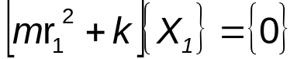

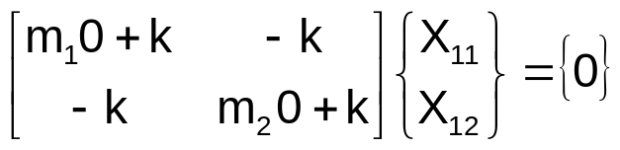
Mode shape #1 (rigid body mode):
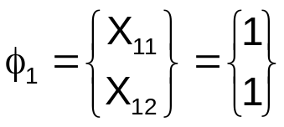
and for the second angular frequency, the X₂ vector satisfies
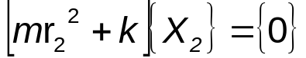

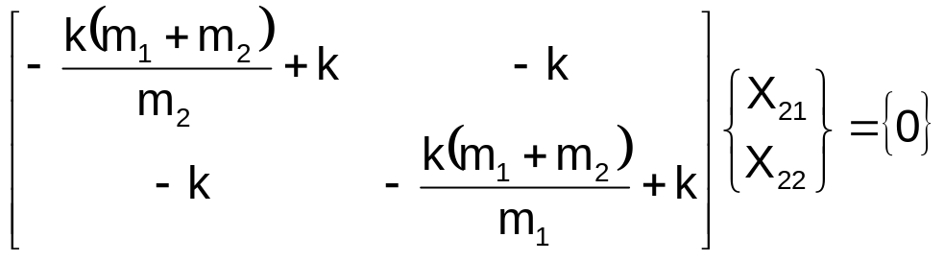
Mode shape #2:
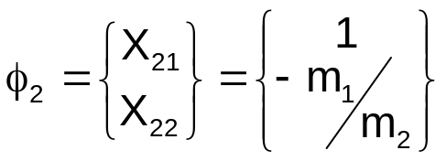
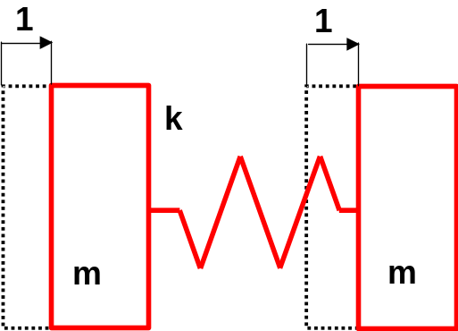
First Mode Shape (rigid body mode)

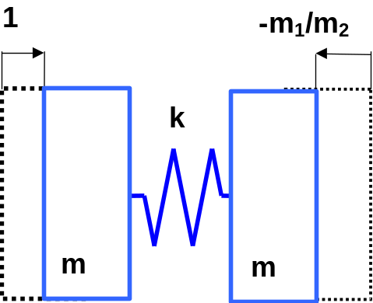
Second Mode Shape
Modal Matrix
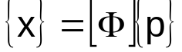
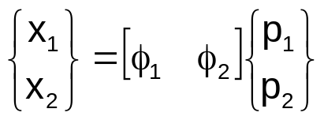

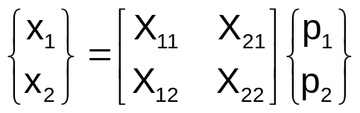
Linear transformation

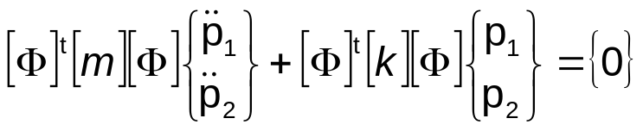
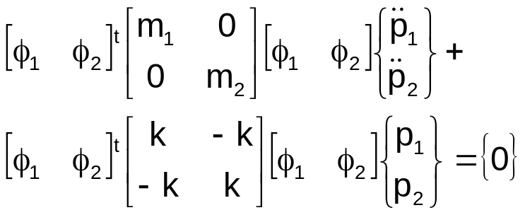

Modal Mass Matrix
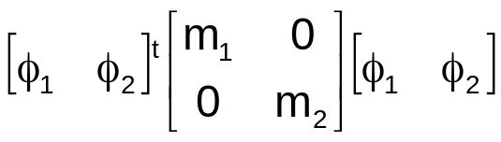
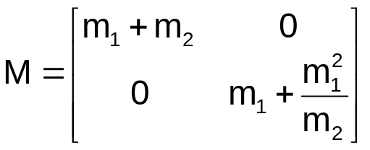

Modal Stiffness Matrix
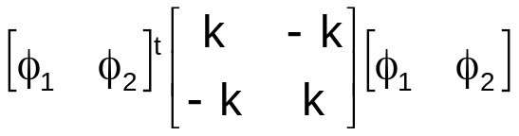
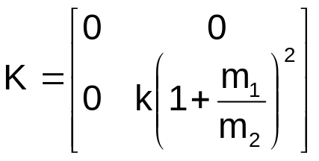
In a modal coordinate system

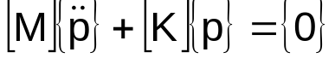

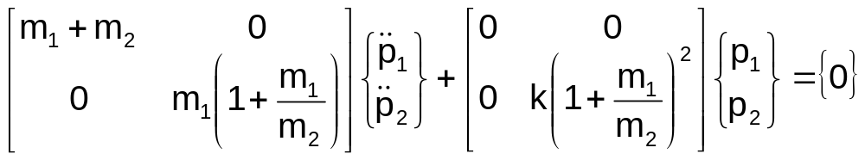
Equations are not coupled

normal Form
both matrices are diagonal
two systems with one-degree-of-freedom

Remind:
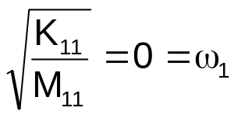
and
